2024.6.15
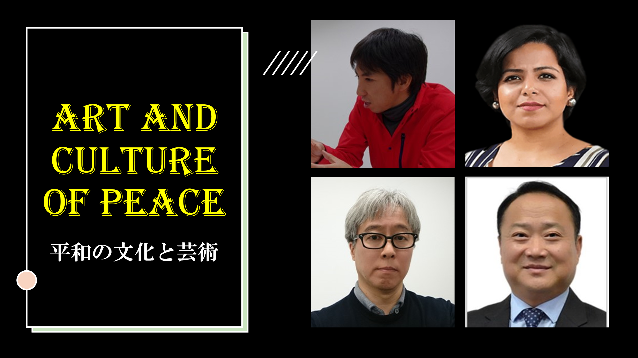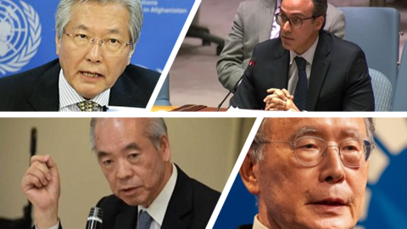

ACUNS Annual Meeting 2024
United Nations University, Tokyo, Japan
FRI-C7 Roundtable
2:00 - 3:15 pm, Friday, 21 June 2024

Art and Culture of Peace In Diversified and Divided World

The Constitution of the United Nations Educational, Scientific and Cultural Organization (UNESCO) states that “since wars begin in the minds of men, it is in the minds of men that the defenses of peace must be constructed.” The United Nations expressed its understanding of peace in its resolution 53/243 of 1999, Declaration and Programme of Action on a Culture of Peace, that “peace not only is the absence of conflict but also requires a positive, dynamic, participatory process where dialogue is encouraged, and conflicts are solved in a spirit of mutual understanding and cooperation,” and recognized that the end of the Cold War had widened possibilities for strengthening a culture of peace.

This working group session will allow the participants to present their understanding of the relationship between culture and peace as the world is again divided by opposing groups with diversified cultures and ideologies. The group will examine, in particular, the core values and principles of

Presenters:
- Shigeyuki KAZAMA, Professor, Kyoto University of the Arts
- Kazuya NAKAYAMA, Professor, Kyoto University of the Arts
- Takahiro SHINYO, Special Advisor to the President and Professor of Kwansei Gakuin University

Commentators:
- Tadamichi YAMAMOTO, Councilor of the Kyoto Peacebuilding Center
- Youssof GHAFOORZAI, Ambassador of Afghanistan in Norway
- Hongsheng SHENG , Professor of Public International Law at the School of International Law, Shanghai University of Political Science and Law, China
- Poulomi BHADRA, Assistant Professor of the Jindal Global University

Moderator:
Sukehiro HASEGAWA, Distinguished Professor, Kyoto University of the Arts

Organizers:
Hiroki NAKAYAMA, Professor, Kyoto University of the Arts
Arbenita SOPAJ, Special Assistant to the Ambassador of the Republic of Kosovo to Japan

Moderator and Speakers

HASEGAWA Sukehiro Special Representative of the Secretary-General of the United Nations for Timor-Leste (2004-2006)
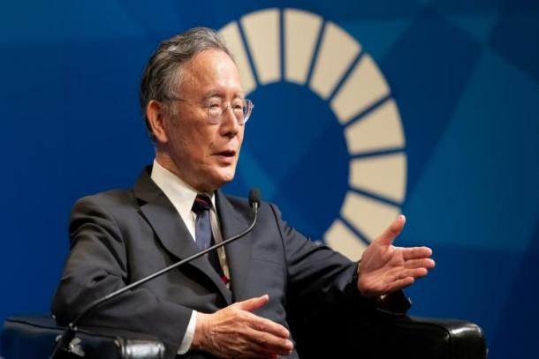
Dr. Hasegawa is the President of the Global Peacebuilding Association of Japan. He was the Special Representative of the Secretary-General of the United Nations for Timor-Leste (2004-2006). He spent 37 years with the UN and served as UN Resident Coordinator in the South Pacific (1985-86), Rwanda (1995-96), and Timor-Leste (2002-2006). He was Deputy Executive Coordinator of the UN Volunteers in Geneva (1987-93), Manager of the UNV Electoral Officers in Cambodia (1993), and Director of Policy and Planning at UNOSOM II (1994). Deputy Assistant Administrator for Asia and the Pacific at UNDP New York (1096-99). Currently, Dr. Hasegawa is the President of the Global Peacebuilding Association of Japan (GPAJ), Director of ACUNS Tokyo Liaison Office, Director of the Kyoto Peacebuilding Center, and Executive Director of Academic Exchange at UN Association of Japan. He obtained his BA from the University of Michigan, MA from the ICU in Tokyo, and Ph.D. from Washington University in St. Louis, USA.

KAZAMA Shigeyuki, Professor, Kyoto University of the Arts
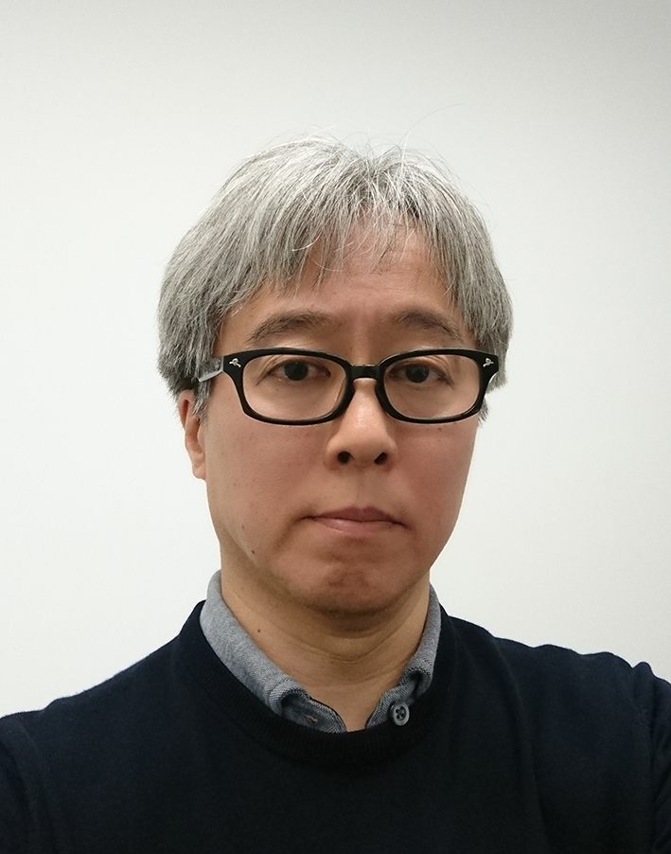
After graduating from Musashino Art University in 1987 with a degree in Craft and Industrial Design, joined Sony Corporation. Responsible for audio/visual equipment design and design management in Japan and the US. In 2006, transferred to Sony Ericsson, managed the global team from Sweden.2009 Transferred to Sony Computer Entertainment, overseeing PlayStation® platform design in Japan and San Francisco. 2018 Sony Corporation, Creative Center, General Manager, before retiring in 2019.

NAKAYAMA Kazuya, Professor, Kyoto University of the Arts

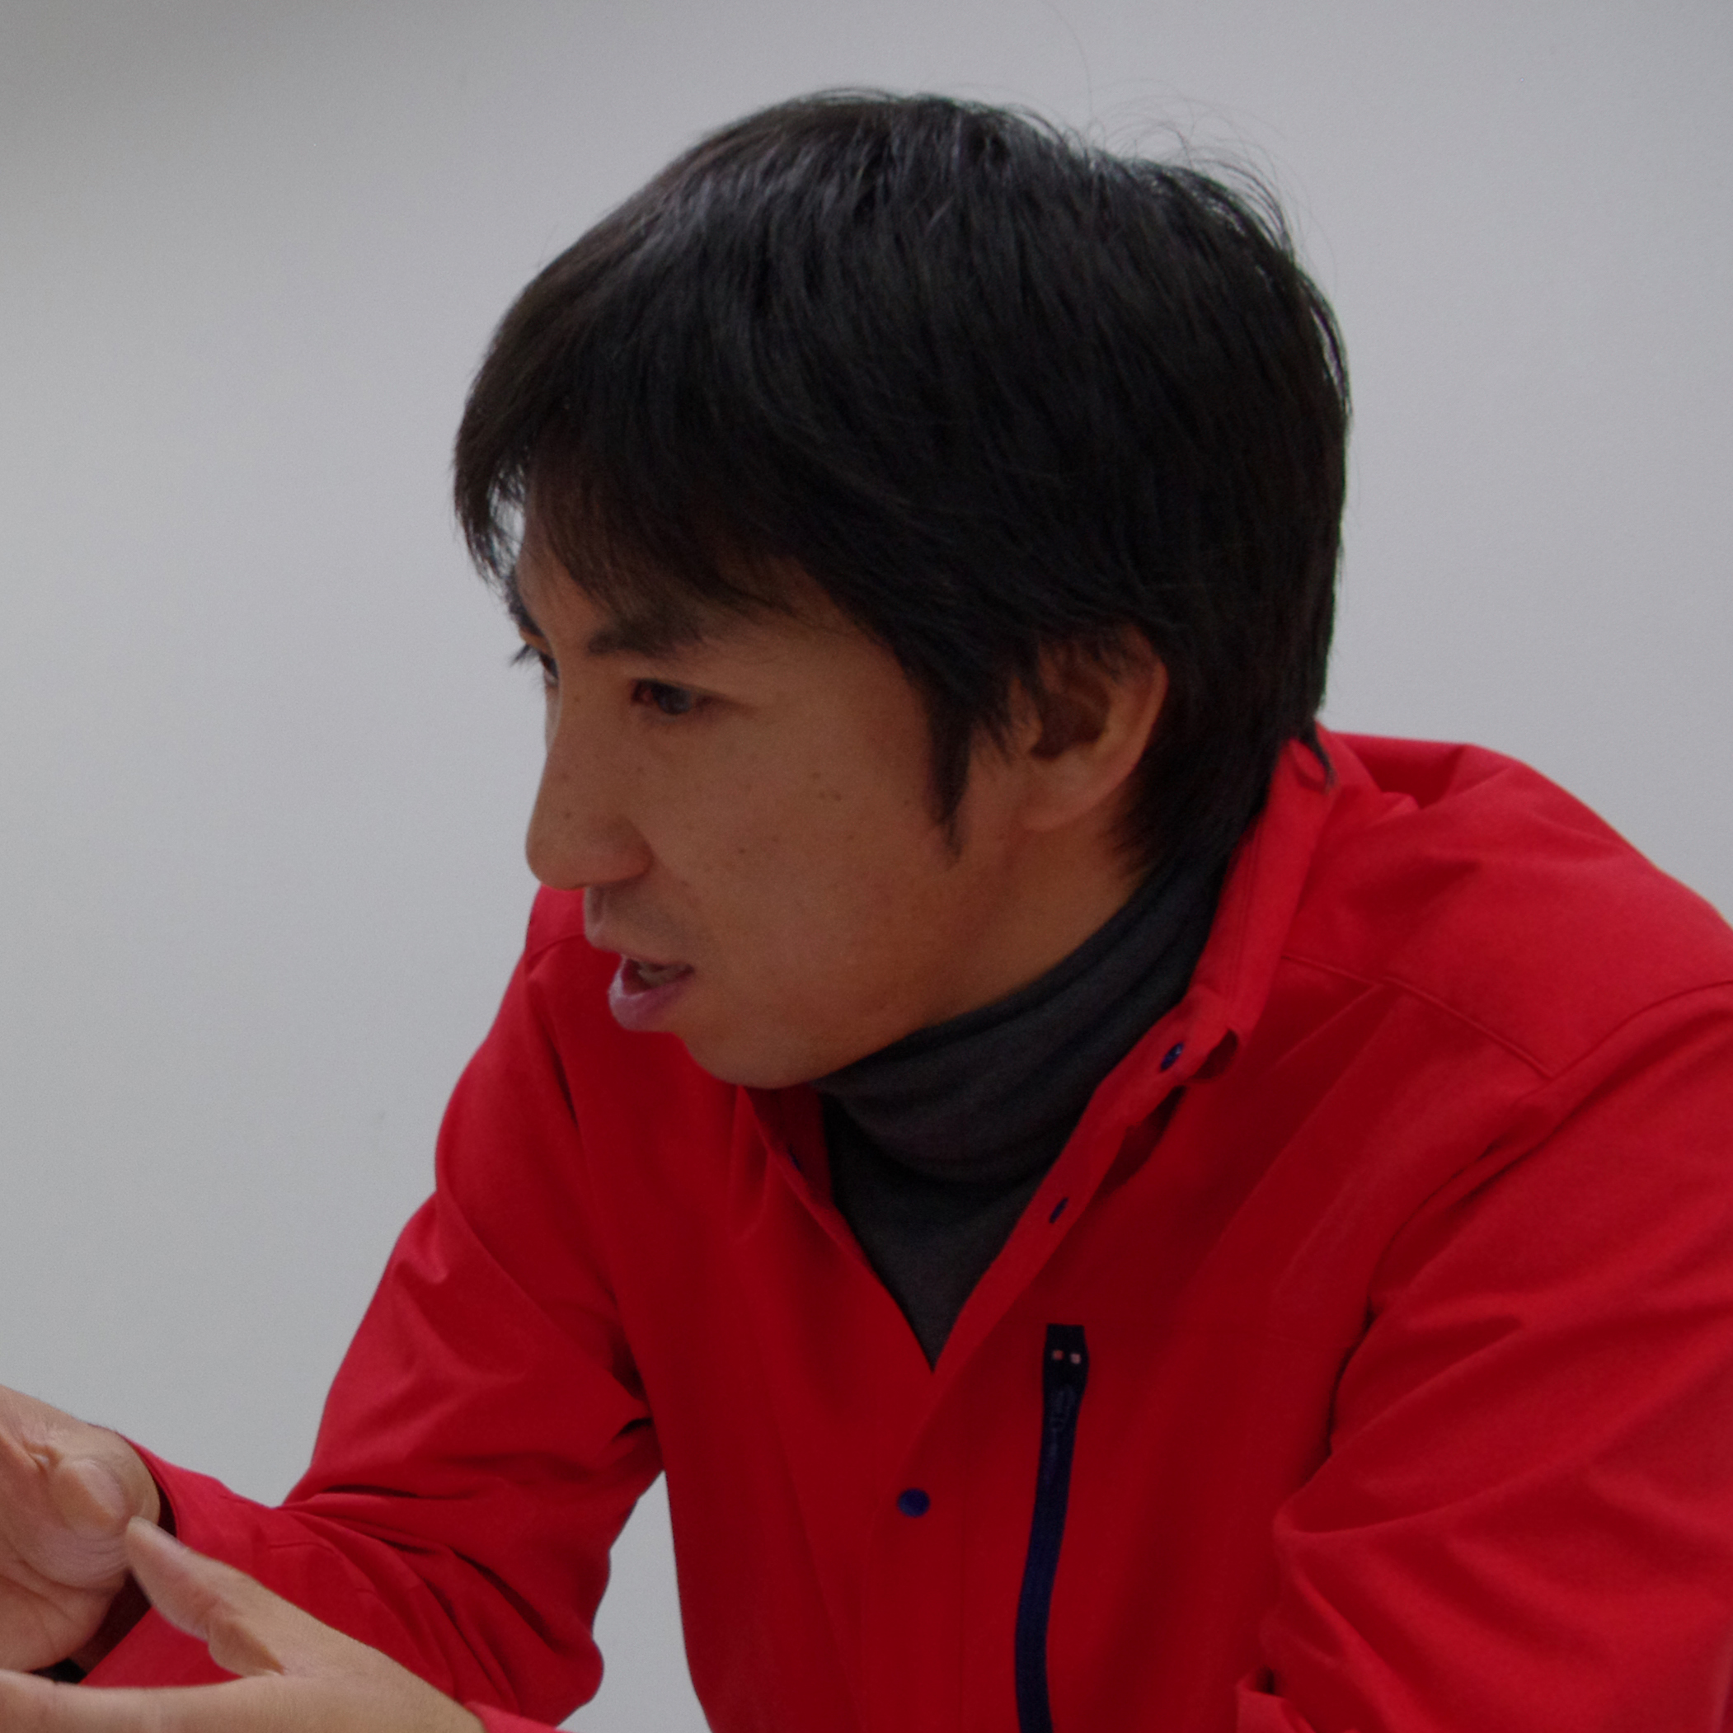
He worked in the ateliers of Jean-Luc Vilmouth, Guillaume Paris, Tadashi Kawamata as a guest researcher at École Nationale Supérieure des Beaux-Arts de Paris, France (until 2017). Recent exhibitions include Partie de campagne (titre parapluie) (Galerie Thaddaeus Ropac, Paris-Pantin), Exhibition of Kuandu Residency Program (Kuandu Museum of Fine Arts, Taipei) and many others. Rather than exhibits some works that are prepared before, focus on what happens in here and now, intuitionally visualizes the feeling of the site. Pushing a beginning of a movement, such as an unexpected encounter for lovers in an impossible circumstance, or a work that to be late for an exhibition, moreover, a work that a summer orange rolls on a slope in a forest, present the situation or outcome that occur as an art work.

SHINYO Takahiro, Former Ambassador to the United Nations and Germany

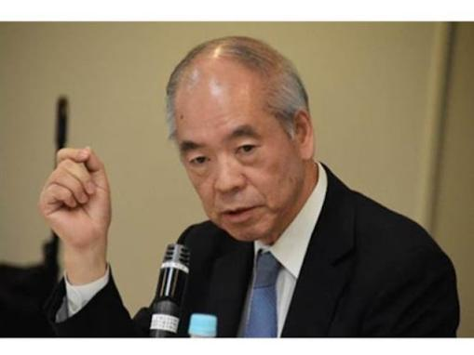
Dr. Shinyo studied law at Osaka University and joined the Japanese Ministry of Foreign Affairs in 1972 and served for 40 years as a diplomat. He served at the Japanese Embassies in Switzerland, China, and Germany. In the Ministry of Foreign Affairs, he served as Director of the Disarmament Division and of UN Policy Division. In 1999, he became Deputy Director-General of the European Affairs Bureau. After serving as Director-General of the Multilateral Cooperation Department, he was appointed in 2005 as Ambassador and Deputy Permanent Representative of Japan to the United Nations. Two years later, he was Ambassador to the Federal Republic of Germany. Upon retirement from the Ministry in 2012, he was appointed Vice-President of Kwansei Gakuin University (2012-2018). He is now serving as Dean and Professor of the Integrated Center for UN and Foreign Affairs Studies at Kwansei Gakuin University.

YAMAMOTO Tadamichi, Secretary-General's Special Representative and Head of the UN Assistance Mission in Afghanistan (UNAMA) from 2016 to 2020.
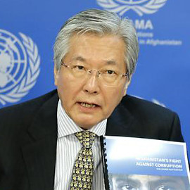
Tadamichi Yamamoto is a diplomat, who served as UN He served as a Japanese diplomat for 40 years from 1974. He was the Director in charge when Japan led the international efforts for peace in Cambodia, 1992-94; Director in charge of North America; Heads of political sections in the Philippines, Republic of Korea and the United States; Director-General for Public Diplomacy; Ambassador to Hungary (2012-2014) and Permanent Representative to UNESCO (2008-2010). He served as the Special Representative of Japan for Assistance to Pakistan and Afghanistan (2010-12), and was in charge of organizing the Ministerial Conference on Assistance to Afghanistan held in Tokyo (July 2012).

GHAFOORZAI Youssof, Ambassador of Afghanistan to Norway

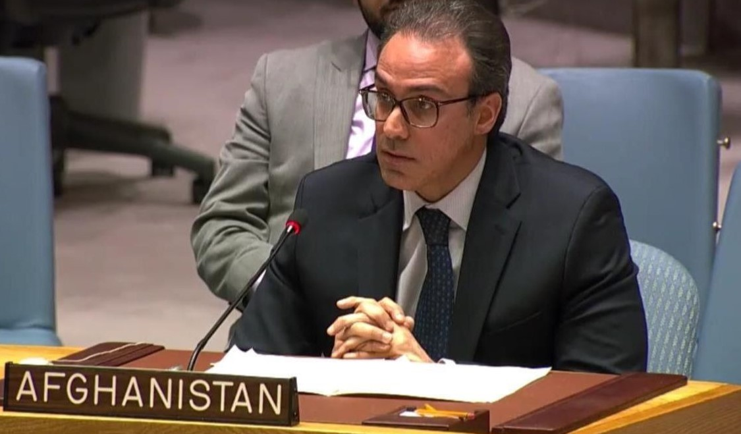
H.E. Mr. Youssof Ghafoorzai is a career diplomat with extensive expertise in multilateral diplomacy, foreign policy, and conflict resolution. He has served at the Permanent Mission of Afghanistan to the United Nations in New York as Political Counselor (2010-2014, 2016-2019), negotiating key UN resolutions on Afghanistan and leading counter-terrorism and sanctions committees. At the Ministry of Foreign Affairs in Kabul, he served as Senior Adviser on International Affairs and was a member of the UN and International Conferences Dept. He has represented Afghanistan in numerous international forums, advocating for peace, stability, and development. Since November 2019, he has been the Ambassador of Afghanistan to Norway, Denmark, and Iceland. Following the Taliban's takeover in August 2021, he has advocated for international engagement to resolve the crisis in Afghanistan through an inclusive political process. Mr. Ghafoorzai holds a bachelor’s degree in Political Science and Government from Queens College, CUNY, with a focus on International Relations and a minor in History.

BHADRA Poulomi, Assistant Professor, Jindal Global University

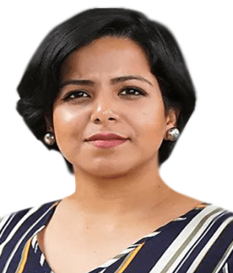
She is Assistant Director and Research Fellow at IDEAS Office of Interdisciplinary Studies. At IDEAS, she is also co-leading the research constellation on Transitional Spaces, Culture and Media Studies. Prior to joining JGU, she has worked at the Natural History Museum, London with the London Metropolitan Police on research in forensic entomology. She has received degrees in criminology and criminal psychology from the University of Essex, UK, in forensic science from King's College London, UK and in Biotechnology from St. Xavier's College, Kolkata, India. Her inter-disciplinary training in STEM and social sciences has helped her innovate and bring her scholarship creatively to look at 'wicked world' problems. Her current research interests focuses on transitional justice and the role of evidence, memory and culture; interdisciplinary pedagogy and curriculum; decolonizing criminology; online hate speech and cyber phenomena; and the role of media in social constructionism.

SHENG Hongsheng
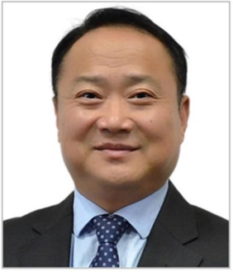
Dr. SHENG Hongsheng is a Professor of Public International Law at the School of International Law, Shanghai University of Political Science and Law, China. He was awarded LL.M (International Criminal Justice and Armed Conflict, Nottingham University, UK) and Ph.D (International Law, Wuhan University, China). From April 2004 to April 2005, he was an Expert on the Mission of the United Nations (MONUC). He was also appointed President of the Independent Board of Enquiry to review international criminal cases. His academic interests focus on public international law, international humanitarian law, and international criminal justice. His publications include six monographs and over sixty articles. He attended Geneva Dialogues between United Nations Officials and Eastern Asian Scholars in 2018 and 2019.

